**LAB # 05**

**Task # 01:**  **Write a program to calculate area of rectangle by using static method. Use parameterized constructor to assign width and height to the instance. Use Output area method which uses the static method to calculate the area.**

**Solution:**

**public static void main(String[] args)** {

Scanner in = new Scanner(System.in);

System.out.print("Enter Lenght OF Rectangle: ");

double l = in.nextDouble();

System.out.print("Enter Width OF Rectangle: ");

double w = in.nextDouble();

Rectangles r1 = new Rectangles(l, w);

r1.Display();

}

**public class Rectangles** {

static double lenght, width;

Rectangles(double l, double h) {

lenght = l;

width = h;

}

public static double area() {

Double a = lenght * width;

return a;

}

void Display() {

System.out.println("length = " + Rectangles.lenght);

System.out.println("width = " + Rectangles.width);

System.out.println("AREA = " + area());

}

}

**Output:**

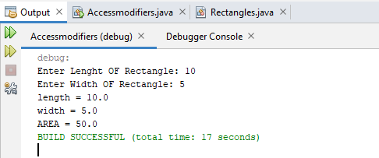

1. **Task # 02: Write a program to display Name, Enrollment Number, University Name and ,Semester of students that are from same university and semester using static fields and methods.(Hint: first set the university name and semester as follows:**



Then use static variable counter to get unique roll numbers as follows:

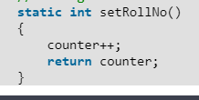

**Solution:**

**public static void main(String[] args)** {

Scanner input = new Scanner(System.in);

char re;

do {

System.out.print("Enter your name: ");

String na = input.next();

Print obj = new Print(na);

Print.setEnrNo();

obj.Display();

System.out.print("Do you want to SAve more Students data: ");

re = input.next().charAt(0);

} while (re == 'y');

}

**public class Print** {

String name;

static int enr_no = 0;

static String uni = "Bahria";

static int sem = 2;

Print(String n) {

name = n;

}

static int setEnrNo() {

enr_no = enr_no + 1;

return enr_no;

}

public void Display() {

System.out.println("--------DATA OF STUDENT " + enr_no + "--------------");

System.out.println("Name = " + name);

System.out.println("ENROLLMENT NO = " + enr_no);

System.out.println("UNIVERSITY NAME = " + uni);

System.out.println("SEMESTER NO = " + sem);

System.out.println("-------------------------------");

}

}

**Output:**

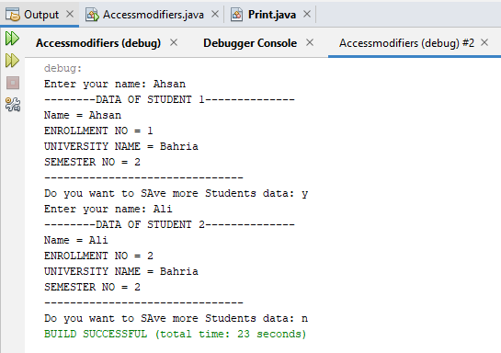

**Task # 03: Write a static method called printNTimes that takes an integer n and a string (in that order) as its parameters and prints the string n times**. For example

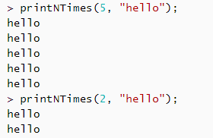

**Solution:**

**public static void main(String[] args)** {

Print.printNTime(5, "AHSAN");

Print.printNTime(3, "OOP");

}

**public class Print** {

static void printNTime(int x,String p){

System.out.println("--------------");

for (int i = 0; i < x; i++) {

System.out.println(p);

}

System.out.println("--------------");

}

}

**Output:**

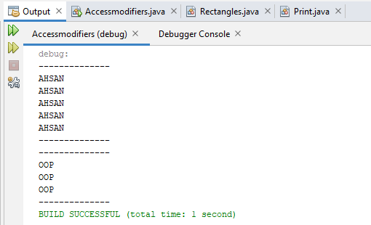

**Task # 04: Write a static method called insult that has two paramaters, a String which represents a person’s name and an integer which represents the persons age. This  
method should create and return a String which is a personal insult based on the value of the argument age that was passed. Use the following age cuttoffs (or variations of your choosing) for creating your insults:**

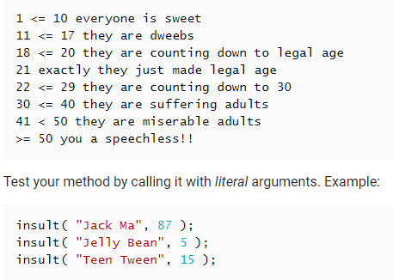

**Solution:**

**public static void main(String[] args)** {

Scanner input = new Scanner(System.in);

char res;

do {

System.out.print("Enter your name: ");

String name = input.next();

System.out.print("Enter your age : ");

int age = input.nextInt();

Print.Insult(name, age);

System.out.print("Do you want to perform again(y/n): ");

res = input.next().charAt(0);

} while (res == 'y');

}

**public class Print** {

static void Insult(String n, int a) {

if (a >= 1 && a <= 10) {

System.out.println("Everyone is sweet --!!!!");

} else if (a > 10 && a <= 17) {

System.out.println("they are dweebs --!!!!");

} else if (a > 17 && a <= 20) {

System.out.println("They are Counting down to legal age --!!!!");

} else if (a == 21) {

System.out.println("They just made legal age --!!!!");

} else if (a > 21 && a <= 29) {

System.out.println("They are Counting down --!!!!");

} else if (a > 29 && a <= 40) {

System.out.println("They are Suffering adults --!!!!");

} else if (a > 40 && a <= 50) {

System.out.println("They are miserable adults --!!!!");

} else {

System.out.println("You are a Speechless!!");

}

}

**Output:**

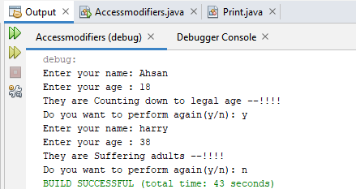

**Task # 05: Write a static method called greetMe that greets you. The method should issue a prompt asking for your name, display a polite (or not so polite) greeting message and then prompt you to enter your age.**

**Solution:**

**public static void main(String[] args)** {

Print.GreetMe();

}

**static void GreetMe()**{

Scanner input=new Scanner(System.in);

System.out.println("---------------------");

System.out.print("Enter your name: ");

String name = input.next();

System.out.println("---------------------");

System.out.println(" Hello " + name);

System.out.println("---------------------");

System.out.print("Enter your age : ");

int age=input.nextInt();

System.out.println("---------------------");

}

**Output:**

